

Sue Darby 907­746­5978 Home 907­­355­3750 Cell sue@sue­a­darby.com www.sue­a­darby.com @suedarby Linkedin/suedarby S

ue is a specialist at bridging the gap between business managers and IT professionals, helping both groups to understand and explain requirements for both users and developers. Sue excels at identifying execution steps, building processes and diagrams with detailed instructions for use. Sue has over 20 years experience with computers and is looking to make a change in career path.

***Computer Skills***

Office Suites: Master Certified MS Office 2003, MS Office 95­2010, MS Outlook, MS Project, MS Visio, MS SharePoint 2007­2010, OneNote, Open Office, Adobe Pro X and XI Databases: MMIS, DS3, Citrix, Access, Enterprise, COGNOS Graphic Art Suites: Corel Draw, Inscape, Gimp, Paint Shop Pro, Visio, Star UML, Dia, Freemind Operating Systems: Windows 3.1­7, DOS 3.3, Ubuntu; Android Open Source: KingSoft Office, Open Office Cloud Based: Evernote, Toodledo, Gmail, Google Drive, Dropbox, TweetDeck, Hootsuite Social Media: Facebook, Twitter, G+, GitHub, Pinterest, YahooGroups, Webrings CMS: WordPress, Drupal, Dreamweaver Programming Languages: HTML, CSS, JavaScript, Perl, VisualBasic.NET, BASIC A

***Technical Achievements***

● Design and implementation of projects:

o “Habilitation Homes Project” to connect licensed homes with certified agencies

o “Critical Incident Report Tracking” system and statistics generation

o Implement final product to reveal compliance issues and regulatory issues

● Administrator of Division Archiving SharePoint as well as subject matter expert for system

o Records retention subject matter expert

● Streamline administrative processes, database improvements, data tracking and report processes

o Generate ad hoc and regular reports on count and status of providers correcting data entry as needed

o Research date & bates stamping equipment purchase to reduce clerical and administrative processing time

o Develop and edit checklists to ensure applications processing efficiency using Visual Basic programming

● Effectively explain ideas and information to both technical and managerial users

o Explain many MS Office skills to others ensuring efficient application use

o Write technical tutorials and processes for future staff reference

o Write business document to correct errors and improve data results for public search tool

o Provide information to help other divisions with efforts to share data

● Manage social media accounts, website and marketing of patterns and books

● Website design, development, including hand coded and Wordpress based websites

● Gather data and develop monthly statistic tracking and reporting for internal use and grant reporting

***Management Achievements***

● Lead, train and delegate tasks to clerical staff

o Contribute input on applicant interviews, selection or termination

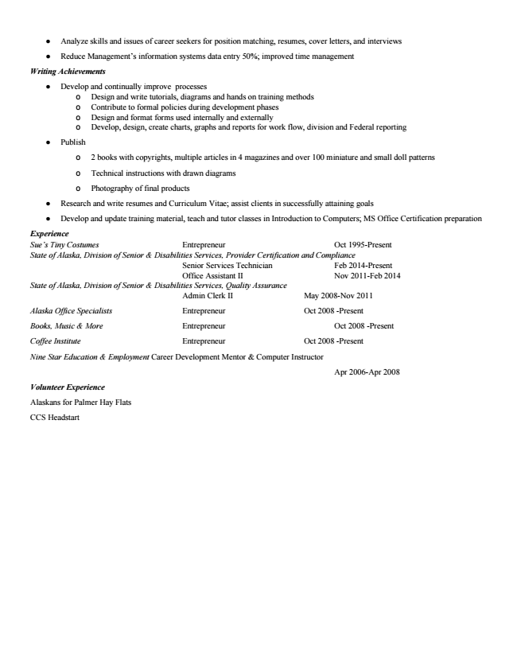

● Analyze skills and issues of career seekers for position matching, resumes, cover letters, and interviews

● Reduce Management’s information systems data entry 50%; improved time management

***Writing Achievements***

● Develop and continually improve processes

o Design and write tutorials, diagrams and hands on training methods o Contribute to formal policies during development phases o Design and format forms used internally and externally o Develop, design, create charts, graphs and reports for work flow, division and Federal reporting

● Publish

o 2 books with copyrights, multiple articles in 4 magazines and over 100 miniature and small doll patterns

o Technical instructions with drawn diagrams

o Photography of final products

● Research and write resumes and Curriculum Vitae; assist clients in successfully attaining goals

● Develop and update training material, teach and tutor classes in Introduction to Computers; MS Office Certification preparation

*Experience Sue’s Tiny Costumes Entrepreneur Oct 1995­Present State of Alaska, Division of Senior & Disabilities Services, Provider Certification and Compliance*

Senior Services Technician Feb 2014­Present Office Assistant II Nov 2011­Feb 2014 State of Alaska, Division of Senior & Disabilities Services, Quality Assurance

Admin Clerk II May 2008­Nov 2011

Alaska Office Specialists Entrepreneur Oct 2008 ­Present

Books, Music & More Entrepreneur Oct 2008 ­Present

Coffee Institute Entrepreneur Oct 2008 ­Present

Nine Star Education & Employment Career Development Mentor & Computer Instructor

Apr 2006­Apr 2008

***Volunteer Experience***

Alaskans for Palmer Hay Flats

CCS Headstart



***Education***

**Charter College Bachelors of Science– Alpha Beta Kappa 3.85 GPA**

*Bachelors of Science Degree ­ Business Management and Technology: Concentration in Business Applications Bachelors of Science Degree ­ Business Management and Technology Associate of Applied Science Degree ­ Computer Science: Concentration in Business Applications Associate of Applied Science Degree ­ Business Management Practice Certificate ­ Computerized Office Associate Certificate ­ Computerized Office Specialist*

Relevant Classes ~Technical Writing Project Management ​~ Statistics ~ Research Methodologies ~ Telecommunications ~ Advanced Web Development ~ Visual Basic.NET ~ Business Law ~ Contract Management ~ Human Resources ~ Operations Management ~ Perl ~ Marketing ~ JavaScript ~

**Self Paced Studies**

~Java ~

**Learnable Courses**

~HTML 5~CSS~JavaScript~PHP MYSQL~Web design ~

**Website Development and Design GNC Web Creations Online**

Business Marketing University Alaska Southeast Juneau, AK

**Certifications**

Microsoft Office 2003 Master Nine Star Education and Employment Anchorage, AK

Training COGNOS 2014 HIPAA Security 201 State of Alaska 2014 Archiving Basics State of Alaska 2012 Introduction to Share Point with Lab State of Alaska 2011 Introduction to Supervisor Training State of Alaska 2011 Basic Care Coordination Training for QA State of Alaska 2010 Introduction to Office 2007 State of Alaska 2009